REffect of dental status on social participation: using a doubly robust estimator

Upul Cooray, Jun Aida, Georgios Tsakos,…

### Introduction

The term "social participation" refers to an individual's involvement in activities that allow them to interact with others in society or the community [@levasseur2010]. Social participation among older adults is regarded as an essential component of healthy aging because it has numerous positive effects on both individuals and society [@Golinowska2016]. Previous studies have linked higher levels of social participation to survival, better health-related quality of life, well-being, and functioning of older adults [@Wanchai2018; @dahan2008]. It is also possible to execute community-level health promotion and prevention activities such as physical activity and smoking and alcohol habit interventions through social engagement [@Saito2019]. However, a variety of socio-demographic and health-related factors have been found to influence the level of social participation among older adults [@Cornwell2009].

Teeth and oral health play an important role in speaking, smiling, and facial expressions, which are essential for positive social interactions. Tooth loss is common in older adults as a result of a life-long accumulation of chronic dental conditions such as dental caries and periodontal diseases [@Griffin2012]. Previous studies have found an association between social participation and dental status in older adults. [@Takeuchi2013]. However, no studies have been conducted to examine how changes in dental status affect social participation. This could be primarily due to the inability to conduct randomised experiments to manipulate individuals' dental status in community settings.

Longitudinal modified treatment policies (LMTPs) are a recently developed non-parametric alternative that can yield the effects of hypothetical interventions such as reducing or increasing exposure by a set amount [@díaz2021]. This framework can be adapted to seek answer to questions such as, "What would have happened to the prevalence of social participation if everyone in the study population increased or decreased their dental status by a certain amount?", "What if everyone who is edentulous became dentate?", and "What if everyone lost their teeth?", utilising observational data. Furthermore, LMTPs can be estimated using sophisticated doubly-robust estimators, such as the targeted maximum likelihood estimator (TMLE), which allows for the use of flexible machine learning predictions [@Laan2011].

This study presents an analysis that estimates the effect of dental status on social participation while taking the time-varying nature of variables into account. We used LMTPs to dynamically change the level of exposure (number of remaining natural teeth) in order to investigate its effect on social participation in community-dwelling older adults in Japan within 6 years of follow-up. A higher number of teeth would, presumably, have a positive impact on social participation. Hence, we hypothesized that as the number of teeth increases, social participation improves, and as the number of teeth decreases, social participation declines among older adults.

**Methods**

#### Data

We used data from the Japan Gerontological Evaluation Study (JAGES) [@Kondo2018]. JAGES is an on-going nationwide cohort study for community-dwelling independent older adults in Japan aged 65 years or over. In this study, data from the 2010 survey as the baseline and two subsequent follow-up surveys (2013 and 2016) were used. We identified 52,053 functionally independent individuals at the baseline survey. Out of them 24,872 individuals had responded to all three waves of JAGES (i.e. 2010, 2013, and 2016). During the 6 years of follow-up 5,561 had died, 7,149 were ineligible as they became functionally dependent, and 14,471 were lost to follow-up due to unknown reasons. A comparison of baseline characteristics by participants follow-up status (died/ became ineligible/ lost to follow-up/ remained) is reported in supplementary table xx.

After excluding participants with missing information for number of teeth in 2010 (n= 669) and social participation in 2016 (n=1,752) a total of 22,451 participants were included in the analyses. The selection of the analytical sample is illustrated in Figure 1. Baseline characteristics of the participants who were excluded due to missing information are compared in supplementary table xx.

#### Outcome variable

Social participation in 2016 was the outcome in this study. JAGES recorded the frequency of participation (“nearly every day,” “twice or thrice a week,” “once a week,” “once or twice a month,” “a few times/year,” “never”) for various social activities. We assessed the frequency of participation in any of the following activities: hobby groups, sports clubs, senior citizens' clubs, residence groups, or volunteer groups. Participation in any of the aforementioned activities once a month or more frequently (vs. less frequently or never) was defined as indicative of social participation (1 = participation, 0 = non-participation).

#### Exposure

The number of remaining natural teeth at the time of the surveys in 2010 and 2013 was used as a time-varying exposure in our analyses. The self-reported number of teeth was recorded using the response to the question, "How many natural teeth do you currently have?" (Instructions: capped/crowned teeth should be counted as "natural teeth"). The responses of participants were recorded in four categories (i.e., 20 teeth/ 10-19 teeth/ 1-9 teeth/ no teeth).

#### Covariates

We controlled our analyses for both time-invariant and time-variant covariates because the number of teeth was assessed as a time-varying exposure. Age (range 65-99 years), sex (male/female) and social participation in 2010 (baseline outcome) were adjusted for as time-invariant covariates. As time-variant covariates, equalised annual household income (million yen), denture use (yes/no), instrumental activities of daily living (IADL) score (0-13), and marital status (married/ single, widowed or divorced) were used (measured in 2010 and 2013).

*Statistical analysis*

The directed acyclic graph (Figure 2) depicts hypothesised temporal relationships between study variables. A descriptive analysis was performed to identify the characteristics of participants stratified by the outcome (social participation in 2016). The counterfactual prevalence of social participation was then estimated using doubly-robust targeted maximum likelihood estimation (TMLE) [@Schuler2016]. In TMLE, the probability of the exposure conditional on covariates (exposure model), and the conditional probability of outcome given exposure and covariates (outcome model) were estimated to obtain unbiased estimation of the counterfactual outcomes [@Laan2006; @Schuler2016]. If either the exposure model or the outcome model was consistently estimated, unbiased estimates could be obtained (hence doubly-robust) [@Laan2012]. To increase the likelihood of robust specification of exposure and outcome models, we used SuperLearner, an ensemble method that uses weighted combinations of multiple machine learning algorithms [@Laan2007; @Rose2019; @Schomaker2019]. Within the SuperLearner, generalized linear models, extreme gradient boosting models, and neural nets were used as candidate algorithms. [@Venables2002; @Chen2016].

In that manner, TMLE was used to estimate the prevalence of social participation under a variety of hypothetical longitudinal intervention policies related to number of teeth. Specifically, Specifically, the following hypothetical intervention policies were investigated:

1. “all participants having ≥20 teeth in 2010 and in 2013,”
2. “all participants having 10-19 teeth in 2010 and in 2013,”
3. “all participants having 1-10 teeth in 2010 and in 2013,”
4. “all participants being edentate in 2010 and in 2013,”
5. “participants deteriorate by one category in terms of number of teeth in 2010 and in 2013 (see Figure 3)”
6. “participants deteriorate by two categories in terms of number of teeth in 2010 and in 2013 (see Figure 3)”
7. “no intervention” (estimation with originally observed data in 2010 and in 2013).

Using the prevalence estimate for the no intervention scenario (observed data) as the reference, we calculated odds ratios (ORs) and their 95% confidence intervals for the mean prevalence estimates of social participation related to the aforementioned different scenarios. As a result, the following contrasts could be investigated:

1. “no intervention” vs “having ≥20 teeth at 2010 and 2013”,
2. “no intervention” vs “having 1-9 teeth at 2010 and 2013”,
3. “no intervention” vs “having 10-19 teeth at 2010 and 2013”,
4. “no intervention” vs “deteriorate by one number of teeth category at 2010 and 2013”,
5. “no intervention” vs “deteriorate by two number of teeth categories at 2010 and 2013”, and
6. “no intervention” vs “being edentulous at 2010 and 2013”.

In addition, a secondary analysis was performed to estimate the effect of denture use on social participation among people with different numbers of teeth. To investigate the effect of denture use, two hypothetical interventions were set up: (1) all participants wearing dentures in 2010 and 2013, and (2) none of the participants wearing dentures in 2010 and 2013. To calculate ORs and 95% CIs, the scenario in which no one wears dentures was used as the reference.

All hypothetical interventions and their contrasts considered in this study are graphically illustrated in the Figure 3. All estimates were appropriately controlled for time-variant and time-invariant covariates.

For imputation of missing data in covariates, we used random forest multivariate imputation by chained equations (MICE). In imputing complex epidemiologic data, random forest MICE has been shown to produce less biased parameter estimates and better confidence interval convergence compared to parametric MICE. [@Shah2014]. We performed our analyses using five imputed datasets and the results were pooled using Rubin’s rules. Distribution of missingness among covariates is reported in supplementary Figure xx.

TMLE method was implemented using lmtp R package [@lmtpR] and the random forest MICE was implemented using *mice* R package [@Buuren2011]. Main R functions used to generate our results are provided in appendix xx. All the other codes used for data preparation and supplementary analyses can be found at <https://github.com/upulcooray/socialParticipation>. All the analyses were conducted in R studio using R version 4.0.5 for Windows x64.

### Results

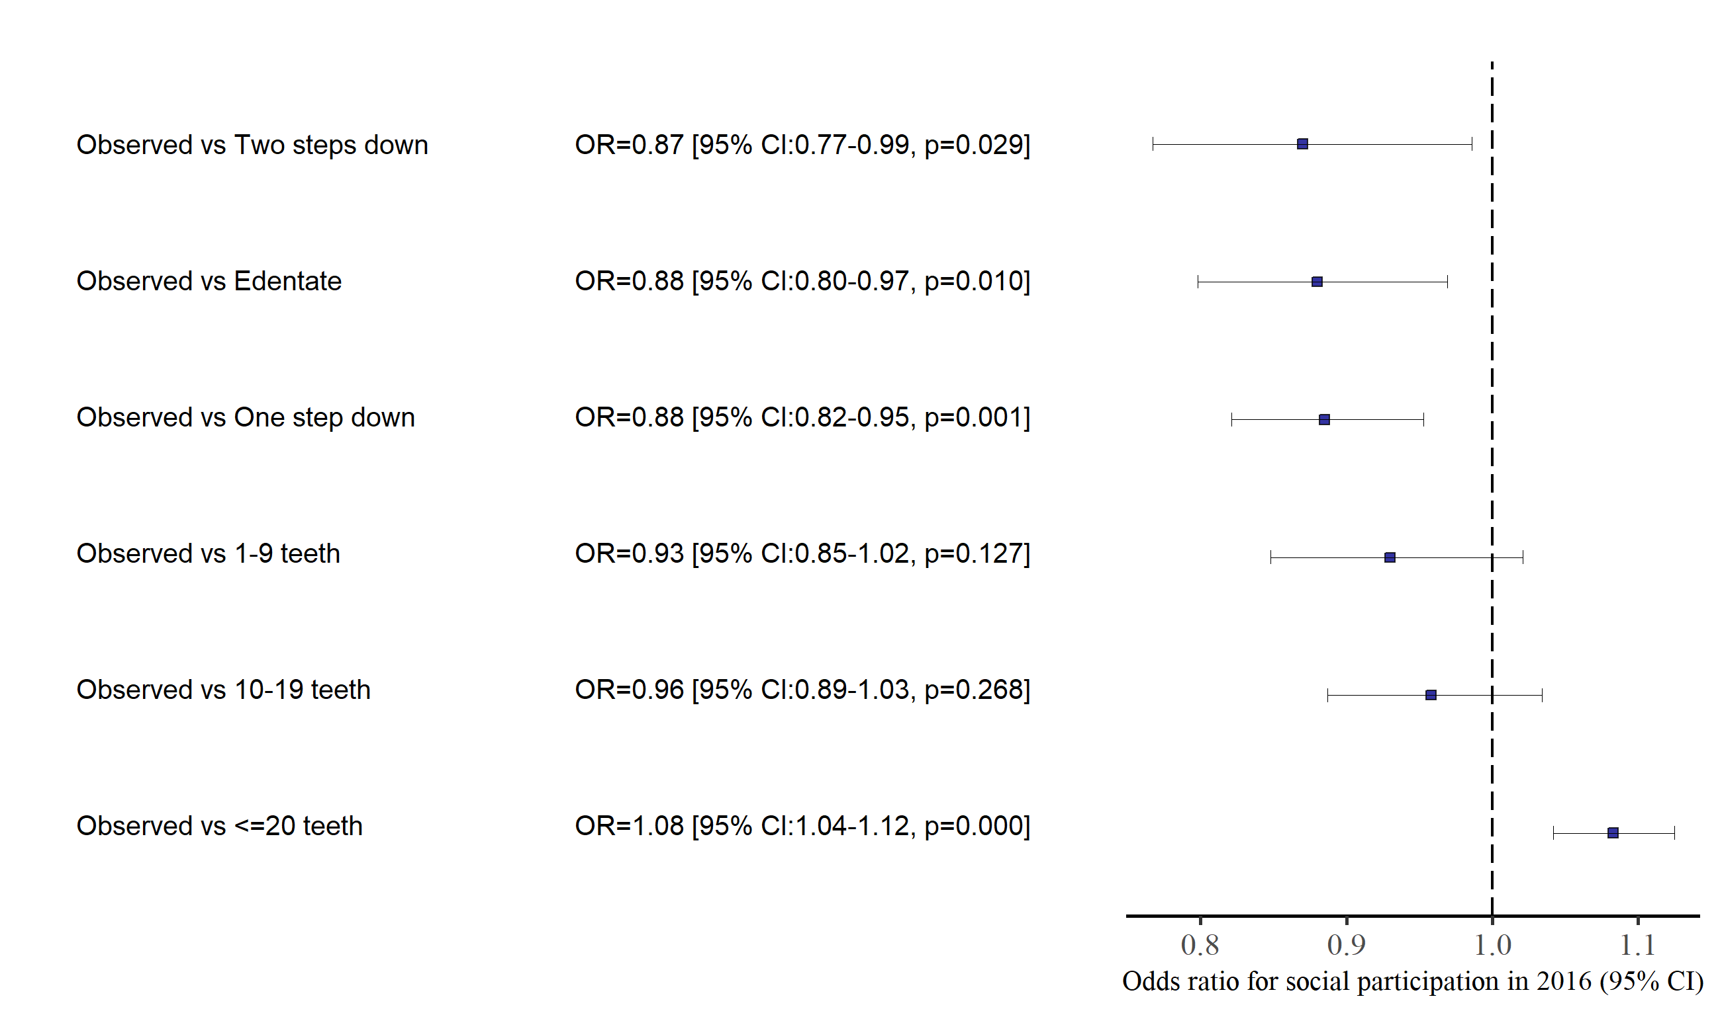Baseline characteristics of the sample stratified by the outcome variable are presented in the Table 1. In the 2016 follow-up, 11,762 people reported a frequency of at least once a month social participation. Baseline characteristics associated with social non-participation in 2016 were older age, lower income, lower IADL score, edentulous or low number of teeth, and lower frequency of social participation at the baseline.

[Figure caption: Odds ratio for social participation under different hypothetical interventions (no intervention as the reference): OR,95% CI, p-value]

Figure xx shows the results of contrasting TMLE estimates related to different longitudinal hypothetical intervention against TMLE estimate of social participation under the exposure observed in data. Getting a relatively lower number of teeth negatively affected social participation during the six-year follow-up. After adjusting for age, sex, baseline social participation and time varying confounders such as annual household income, IADL score, denture use, and marital status consistent exposure to edentulousness would have lower the likelihood of social participation by 12% (OR= 0.88 & 95%CI= 0.80,0.97). Similarly, the odds of social participation was lower if everyone in the sample population deteriorate their dental status by one step in terms of number of teeth category (OR= 0.88 & 95%CI= 0.82,0.95), the On the other hand, continuously being in 20 or more teeth category improved the social participation by 8% (OR= 1.08 & 95%CI= 1.04,1.12).

Results related to the effect of denture use on social participation for different number of teeth categories are shown in Figure xx.

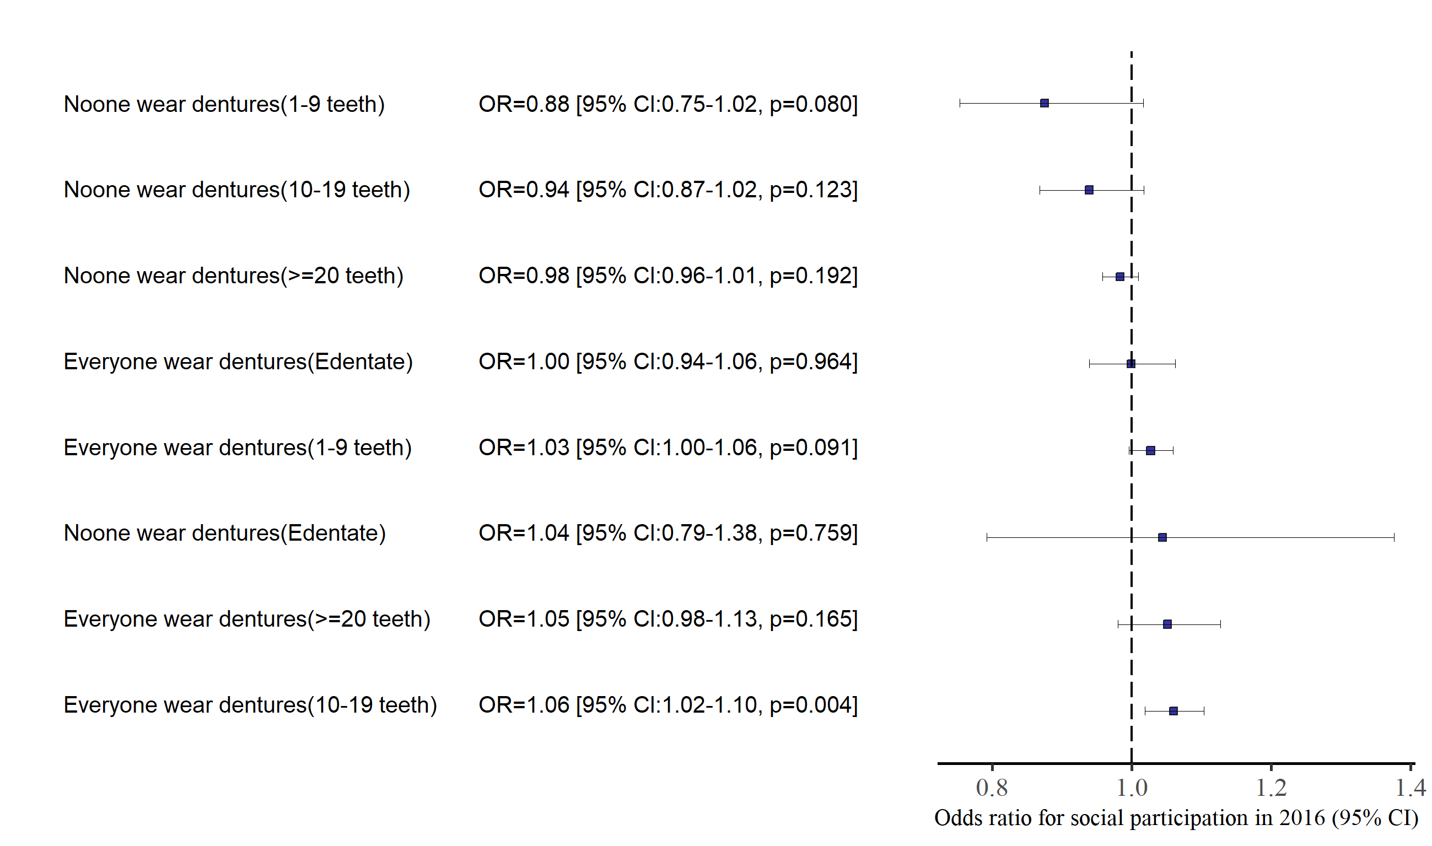

[Figure caption: Odds ratio for social participation for different number of teeth categories under hypothetical denture status levels (observed denture status as the reference): OR,95% CI, p-value]

General trend of the results showed a positive effect of denture wear on social participation for all number of teeth categories. 10-19 teeth category showed the highest beneficial effect of wearing dentures for social participation (OR= 1.06 & 95%CI= 1.02,1.10). Surprisingly, among edentate group in our study population, social participation did not appear to be much affected by denture status.